JDP Days: Talking about Arts & Archaeology
Workshop of the Joined Doctoral Program in Arts and Archaeology
Università di Verona – Universiteit Gent
Verona, 3-4 June 2019

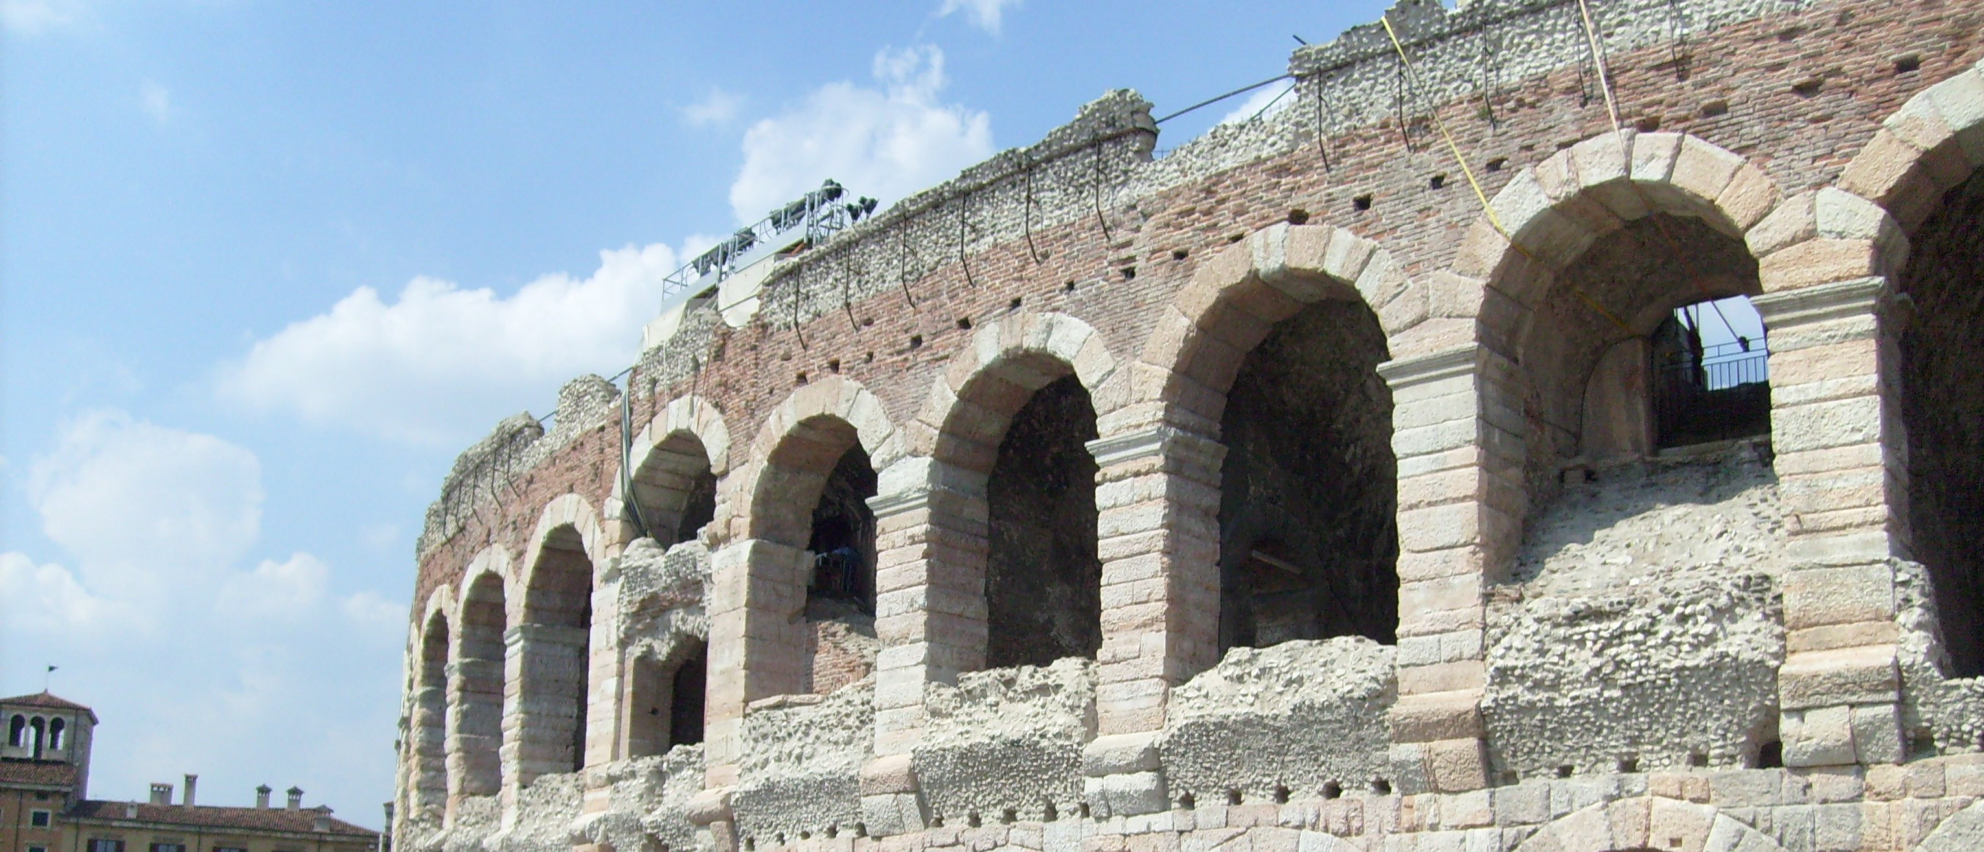

Monday 3rd June: Talking about Archaeology

Venue: Polo Zanotto, aula D4 Olimpia
via San Francesco 22 - Verona

9.45 Welcome by Prof. Attilio Mastrocinque
10.00 Richard Gordon, “Staging Religious Experience in the Mithraic Temple: Mystagagues and Meanings”
10.45 Giovanna Bianchi, “Studying an early medieval Tuscan landscape: from the investigation strategy to the historical interpretation”
11.15 Enrico Zanini, “Vignale: a villa, a mansio, and then...?”
11.45 Brief presentation of the Verona/Gent PhD Students and their projects:
Vittoria Canciani, Michele Abballe, Andrea Zemignani, Celeste Fiorotto

12.30 Lunch

15.00 Verona Romana tour with Prof. Patrizia Basso

Tuesday 4th June: Talking about Art History and Diagnostics

Venue: Polo Zanotto, aula D4 Olimpia
via San Francesco 22 - Verona

9.45 Welcome by Prof. Bernard Aikema
10.00 Jill Dunkerton, “Restored to the Light: Giovanni Bellini’s The Assassination of Saint Peter Martyr in the National Gallery, London”
10.30 Teresa Esposito,”Peter Paul Rubens, ‘A Student of Nature in Post-Tridentine Europe’”
11.00 Piero Boccardo, “Rubens and Van Dijck at Genova: context and results”.

11.30 Brief presentation of the Verona/Gent PhD Students and their projects with a discussion led by Maximiliaan Martens:
Carlotta Striolo, Nicole de Manincor, Maddalena Oldrizzi, Sabrina Lind

12.30 Lunch

15.00 Castelvecchio Museum tour with the directress Francesca Rossi and Prof. Bernard Aikema

